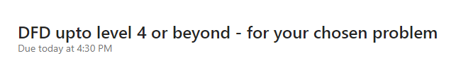

**2022503003**

**NOUN:**

User

Admin

Bank

Reservation db

Report db

Parking db

User db

Vehicle db

Payment db

**Verb:**

Vehicle

Entry

Exit make

Process

View

Update

Print

Manage

**LEVEL-0:**

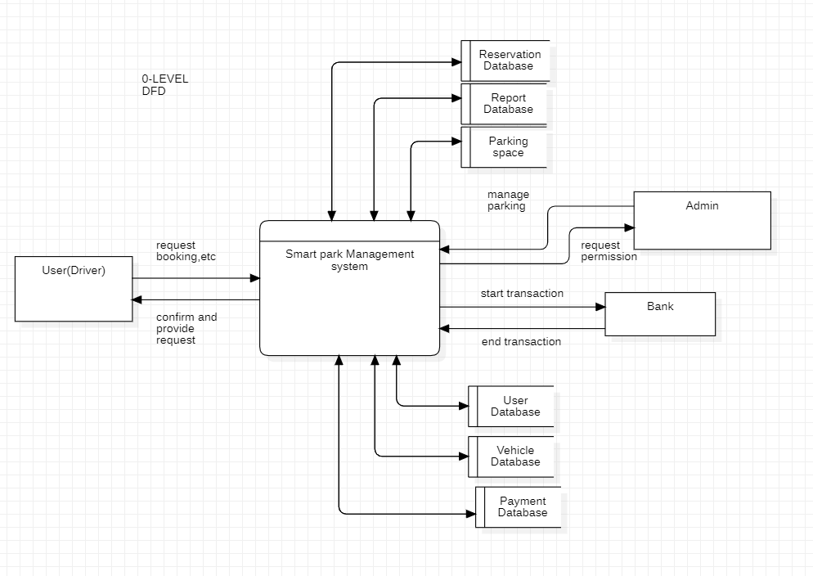

**LEVEL-1:**

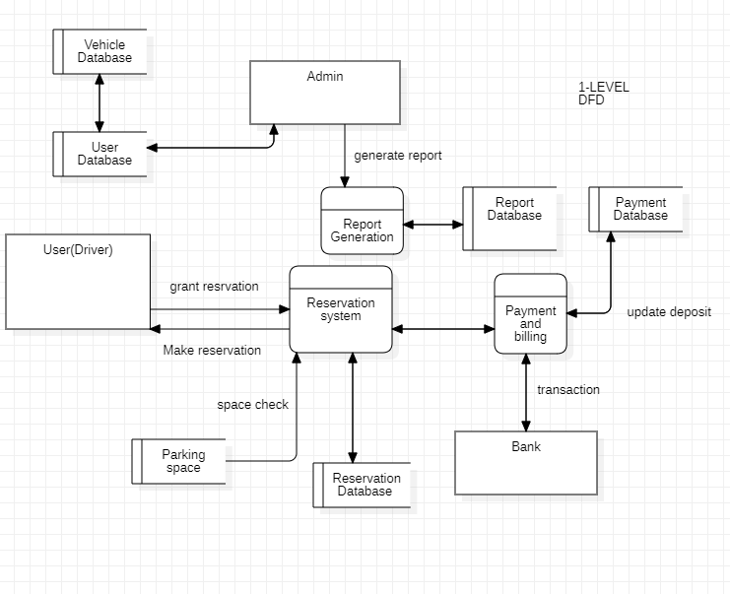

**LEVEL-2:**

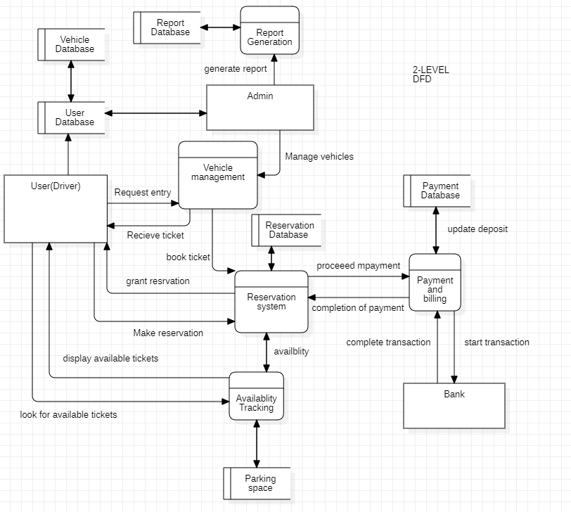

**LEVEL-3:**

